**Task No. 2:** Write a sketch to interface Arduino with Seven Segment Display. It should work as a decade counter. The Start / Stop of counting should be controlled through a SPDT Switch.

**Solution:**

#define segA 2

#define segB 3

#define segC 4

#define segD 5

#define segE 6

#define segF 7

#define segG 8

#define button 10

for (int i=2;i<9;i++){

pinMode(i,OUTPUT); }

void loop(){

ButtonState=digitalRead(button); if(ButtonState==HIGH){

switch (COUNT){

case 0:

digitalWrite(segA, HIGH);

digitalWrite(segB, HIGH);

digitalWrite(segC, HIGH);

digitalWrite(segD, HIGH);

digitalWrite(segE, HIGH);

digitalWrite(segF, HIGH);

digitalWrite(segG, LOW);

break;

case 1:

digitalWrite(segA, LOW);

digitalWrite(segB, HIGH);

digitalWrite(segC, HIGH);

digitalWrite(segD, LOW);

digitalWrite(segE, LOW);

digitalWrite(segF, LOW);

digitalWrite(segG, LOW);

break;

case 2:

digitalWrite(segA, HIGH);

digitalWrite(segB, HIGH);

digitalWrite(segC, LOW);

digitalWrite(segD,HIGH);

digitalWrite(segE, HIGH);

digitalWrite(segF, LOW);

digitalWrite(segG, HIGH);

break;

case 3:

digitalWrite(segA, HIGH);

digitalWrite(segB, HIGH);

digitalWrite(segC, HIGH);

digitalWrite(segD, HIGH);

digitalWrite(segE, LOW);

digitalWrite(segF, LOW);

digitalWrite(segG, HIGH); break;

case 4:

digitalWrite(segA, LOW);

digitalWrite(segB, HIGH);

digitalWrite(segC, HIGH);

digitalWrite(segD, LOW);

digitalWrite(segE, LOW);

digitalWrite(segF, HIGH);

digitalWrite(segG, HIGH);

break;

case 5:

digitalWrite(segA, HIGH);

digitalWrite(segB, LOW);

digitalWrite(segC, HIGH);

digitalWrite(segD, HIGH);

digitalWrite(segE, LOW);

digitalWrite(segF, HIGH);

digitalWrite(segG, HIGH);

break;

case 6:

digitalWrite(segA, HIGH);

digitalWrite(segB, LOW);

digitalWrite(segC, HIGH);

digitalWrite(segD, HIGH);

digitalWrite(segE, HIGH);

digitalWrite(segF, HIGH);

digitalWrite(segG, HIGH);

break;

case 7:

digitalWrite(segA, HIGH);

digitalWrite(segB, HIGH);

digitalWrite(segC, HIGH);

digitalWrite(segD, LOW);

digitalWrite(segE, LOW);

digitalWrite(segF, LOW);

digitalWrite(segG, LOW);

break;

case 8:

digitalWrite(segA, HIGH);

digitalWrite(segB, HIGH);

\digitalWrite(segC, HIGH);

digitalWrite(segD, HIGH);

digitalWrite(segE, HIGH);

digitalWrite(segF, HIGH);

digitalWrite(segG, HIGH);

break;

case 9:

digitalWrite(segA, HIGH);

digitalWrite(segB, HIGH);

digitalWrite(segC, HIGH);

digitalWrite(segD, HIGH);

digitalWrite(segE, LOW);

digitalWrite(segF, HIGH);

digitalWrite(segG, HIGH);

break; }

if (COUNT<10){

COUNT++;

delay(1000);}

if (COUNT==10){

COUNT=0;

delay(1000);}}

**Output:**

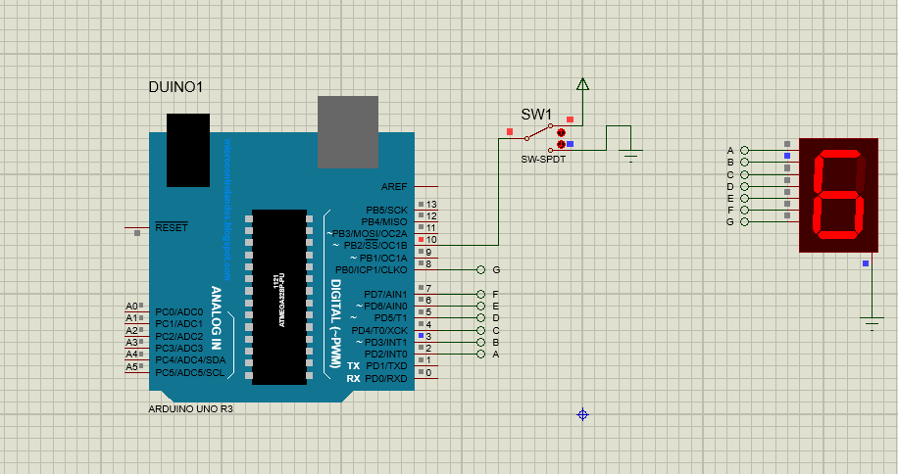

Bahria University,

Karachi Campus



LAB EXPERIMENT NO.

3

LIST OF TASKS

|  |  |
| --- | --- |
| TASK NO | OBJECTIVE |
| **1** | Write a sketch to interface Arduino with 16x2 Liquid Crystal Display (LCD). Write the name of your course “Embedded Systems” in the 1st Line and your Section “BEE - 8A/8B” in the 2nd Line of LCD. This Text should blink with a delay of 0.5 seconds. |
| 2 | Write a sketch to interface Arduino with 16x2 Liquid Crystal Display (LCD). First  line of LCD should display your name, second line of LCD should display your  registration number, and text in both line should keep moving from left to right. |

Submitted On:

20/10/2022

(Date: DD/MM/YY)

**Task No. 1:** Write a sketch to interface Arduino with 16x2 Liquid Crystal Display (LCD). Write the name of your course “Embedded Systems” in the 1st Line and your Section “BEE- 8A/8B” in the 2nd Line of LCD. This Text should blink with a delay of 0.5 seconds.

**Solution:**

#include <LiquidCrystal.h> LiquidCrystal lcd(12, 11, 5, 4, 3, 2);

void setup(){

lcd.begin(16, 2); // Setting Up the LCD No. of Rows & Columns }

void loop(){

lcd.setCursor(0, 0);

lcd.print("Embedded Systems");

lcd.setCursor(0, 1);

lcd.print("BEE - 8A/8B");

delay(500);

lcd.clear();

delay(5000); }

**Output:**

**Task No. 2:** Write a sketch to interface Arduino with 16x2 Liquid Crystal Display (LCD). First line of LCD should display your name, second line of LCD should display your registration number, and text in both line should keep moving from left to right.

**Solution:**

#include <LiquidCrystal.h> LiquidCrystal lcd(12, 11, 5, 4, 3, 2);

void setup(){

lcd.begin(16, 2); // Setting Up the LCD No. of Rows & Columns }

void loop(){

lcd.setCursor(0, 0);

lcd.print("Muhammad Abdullah");

lcd.setCursor(0, 1);

lcd.print("Reg# 70000");

delay(500);

lcd.clear();

delay(5000); }

**Output:**